NORTH WEST REGION

22

AGRICULTURE STD 5
TERM 2
ANSWER ALL QUESTIONS 50 MARKS

Mr. Kashweeka has tried number of was to earn a living and has never been successful. Now he wants to try agriculture so that he can be able to live better but the problem is he has a very little knowledge about agriculture. Suppose you are to advise him about anything he wants to know about agriculture

- Describe what agriculture is for him? (1 mark)
________________________________________________________________________________________________________________________________________________

- Give one system of agriculture you would like Mr. Kashweeka to practice and two reasons why you prefer it?
System_________________________________________________________ (1mark)
Reasons______________________________________________________________________________________________________________________________ (2 marks)
- State how the following government programmes can assist him? (2 marks
CEDA________________________________________________________________
ISPAAD_______________________________________________________________
________________________________________________________________________

- What is the difference between pastoral and arable farming? (2 marks)
_________________________________________________________________________________________________________________________________________________________________________________________________________________________________

- Discuss any two ways by which HIV/AIDS can affect productivity in agriculture (2 marks)
________________________________________________________________________________________________________________________________________________________________________________________________________________________

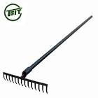
- What is the use of the above farm tool? (1 mark)
________________________________________________________________________

- The farmer painted the tool with a white paint. How is this helpful to the tool? (1 mark)
________________________________________________________________________________________________________________________________________________
- Why should we avoid using farm implement when it is too wet? (1 mark)
________________________________________________________________________________________________________________________________________________
- Explain the difference between traditional and modern biotechnology.
______________________________________________________________________________________________________________________________________________________________________________________________________________(2 marks)
- Give any two products which are result of using traditional biotechnology (2 marks)
____________________________________
____________________________________
- State three ways which modern biotechnology can be used to solve agricultural problems? (3 marks)
________________________________________________________________________________________________________________________________________________________________________________________________________________________________________________________________________________________________
_______________________________________

Use the information to answer question 12 (I and ii) (1 mark)

Mr. Uri owns a 100 hectares farm a tractor a combined harvester and a borehole. He plants the whole and supplies local stores

- Which system of farming is practiced by Mr. Uri? _________________________
ii. Which level of production is he practicing? (1 mark)
____________________________________________________________________ (1mark)
- What is germination? (1 mark)
________________________________________________________________________________________________________________________________________________
- List three ways that can be done to improve soil fertility (3 marks)
________________________________________________________________________________________________________________________________________________________________________________________________________________________
- Describe any two careers in the field of agriculture? (4 marks)
________________________________________________________________________________________________________________________________________________________________________________________________________________________
________________________________________________________________________

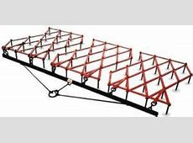
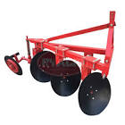
W X
- Name the implement labeled w (1 mark)
_______________________________________
(b) State the uses of the implements w and x (2 marks)
________________________________________________________________________________________________________________________________________________

The illustration below shows the proportion of soil constituents in a normal soil sample. Use it to answer question 17 (a and b)

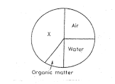
- Name the soil constituents labeled x (1 mark)
______________________________________________________________________
b) Which soil constituents make quarter of the soil? (1 mark)
________________________________________________________________________

- State two advantages of adding organic fertilizers to the soil (2 marks)
________________________________________________________________________________________________________________________________________________

Study the diagrams below and use them to answer question 19

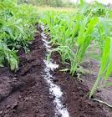
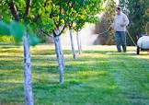
- Name the methods use above to apply fertilizer (2 marks)
________________________________________________________________________________________________________________________________________________

- State two positive effect of biotechnology (2 marks)
________________________________________________________________________________________________________________________________________________________________________________________________________________________
- List two importance of agriculture (2 marks)
________________________________________________________________________________________________________________________________________________

Standard 5 pupils in Disaneng primary school were asked to grow spinach. They planted the seeds in a seedbed (plot) and cover it with dry grass.

- Which management practice was being carried out?
__________________________________________________________________ (1 mark)
- Give two problems faced by farmers in Botswana and give each problem a solution (4 marks)
Problem _______________________________________________________________
Solution________________________________________________________________

Problem_______________________________________________________________
Solution________________________________________________________________

- Define the term weathering (1 mark)
________________________________________________________________________________________________________________________________________________________________________________________________________________________
- List one type of weathering (1 mark)
________________________________________________

